Case Study

Olympic Game

1. How many olympics games have been held?

SELECT COUNT(DISTINCT games) total_games

FROM athlete_events

2. List down all Olympics games held so far.

SELECT DISTINCT year, season, city

FROM athlete_events

3. Mention the total no of nations who participated in each olympics game?

SELECT games, COUNT(DISTINCT region) Country_num

FROM athlete_events ae

JOIN noc_regions nr

ON nr.NOC = ae.noc

GROUP BY games

ORDER BY Country_num

4. Which year saw the highest and lowest no of countries participating in olympics?

WITH temp AS(

SELECT games, COUNT(DISTINCT region) Country_num,

RANK() OVER(ORDER BY COUNT(DISTINCT region) DESC) rnk

FROM athlete_events ae

JOIN noc_regions nr

ON nr.NOC = ae.noc

GROUP BY games)

SELECT * FROM temp

WHERE temp.rnk = 1 OR temp.rnk = (SELECT MAX(rnk) FROM temp)

Another format:

WITH cte AS (

SELECT games, COUNT(DISTINCT region) country_num,

CONCAT(FIRST_value(games) OVER(ORDER BY COUNT(DISTINCT region) DESC), '-',

FIRST_value(COUNT(DISTINCT region)) OVER(ORDER BY COUNT(DISTINCT region) DESC)) height_game,

CONCAT(FIRST_value(games) OVER(ORDER BY COUNT(DISTINCT region)), '-',

FIRST_VALUE(COUNT(DISTINCT region)) OVER(ORDER BY COUNT(DISTINCT region))) lowest_game

FROM athlete_events ae

JOIN noc_regions nr

ON nr.noc = ae.noc

group by games)

SELECT height_game, lowest_game

FROM cte

LIMIT 1

5. Which nation has participated in all of the olympic games?

WITH cte AS (

SELECT region, COUNT(DISTINCT games) total_participated,

RANK() OVER(ORDER BY COUNT(DISTINCT games) DESC) rnk

FROM athlete_events ae

JOIN noc_regions nr

ON nr.noc = ae.noc

GROUP BY region

HAVING COUNT(DISTINCT games) = COUNT(DISTINCT games))

SELECT region, total_participated FROM cte

WHERE rnk = 1

6. Identify the sport which was played in all summer olympics.

SELECT sport, COUNT(*)

FROM (

SELECT games, sport,

ROW_NUMBER() OVER(PARTITION BY games)

FROM athlete_events

WHERE games LIKE '%Summer%'

GROUP BY games, sport)

GROUP BY sport

HAVING COUNT(*) = (SELECT COUNT(DISTINCT games) FROM athlete_events WHERE games LIKE '%Summer%')

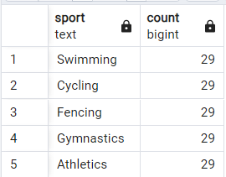

7. Which Sports were just played only once in the olympics?

SELECT sport, COUNT(*)

FROM (

SELECT games, sport,

ROW_NUMBER() OVER(PARTITION BY games)

FROM athlete_events

GROUP BY games, sport)

GROUP BY sport

HAVING COUNT(*) = 1

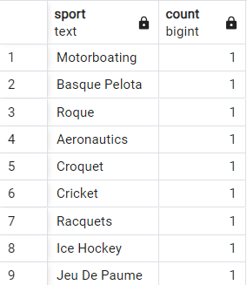

8. Fetch the total no of sports played in each olympic games.

SELECT games, COUNT(DISTINCT sport) total_sports

FROM athlete_events

GROUP BY games

ORDER BY total_sports DESC

9. Fetch details of the oldest athletes to win a gold medal.

SELECT *

FROM(

SELECT id, name, sex, age, height, weight, team,

RANK() OVER(ORDER BY age DESC) as rnk

FROM athlete_events

WHERE medal = 'Gold' AND (age <= (SELECT MAX(age) FROM athlete_events)) ) temp

WHERE temp.rnk = 1

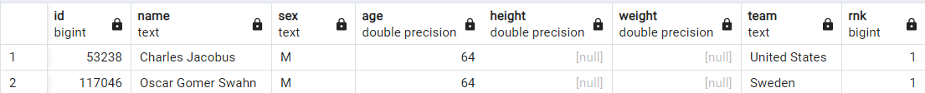

10. Find the Ratio of male and female athletes participated in all olympic games.

WITH main as (

SELECT sex, COUNT(*) total_num_gender

FROM athlete_events

GROUP BY sex),

female as(

SELECT total_num_gender,

ROW_NUMBER() OVER() rn

FROM main

WHERE sex = 'F'),

male as (

SELECT total_num_gender,

ROW_NUMBER() OVER() rn

FROM main

WHERE sex = 'M'

)

SELECT CONCAT('1:', ROUND((male.total_num_gender::NUMERIC / female.total_num_gender::NUMERIC) ,2)) ratio

FROM female

JOIN male

ON male.rn = female.rn

11. Fetch the top 5 athletes who have won the most gold medals.

SELECT id, name, COUNT(*) num_gold,

RANK() OVER(ORDER BY COUNT(*) DESC) rnk

FROM athlete_events

WHERE medal = 'Gold'

GROUP BY id, name

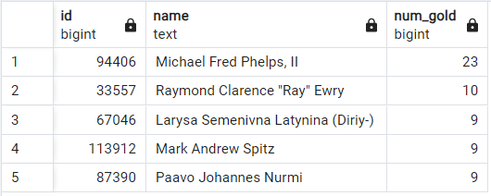

12. Fetch the top 5 athletes who have won the most medals (gold/silver/bronze).

WITH cte AS (

SELECT id, name, COUNT(*) num_medal,

RANK() OVER(ORDER BY COUNT(*) DESC) rnk

FROM athlete_events

WHERE medal in ('Gold', 'Silver', 'Bronze')

GROUP BY id, name)

SELECT id, name, num_medal

FROM cte

WHERE rnk < 6

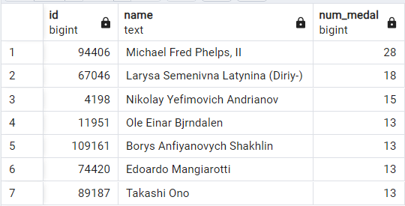

13. Fetch the top 5 most successful countries in olympics. Success is defined by no of medals won.

WITH cte AS(

SELECT region, COUNT(*) num_medals,

RANK() OVER(ORDER BY COUNT(*) DESC) rnk

FROM athlete_events ae

JOIN noc_regions nr

ON nr.noc = ae.noc

WHERE medal in ('Gold', 'Silver', 'Bronze')

GROUP BY region

ORDER BY num_medals DESC)

SELECT region, num_medals

FROM cte

WHERE rnk < 6

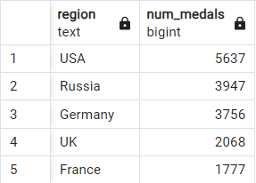

14. List down total gold, silver and broze medals won by each country.

SELECT region, SUM(CASE

WHEN medal = 'Gold' THEN 1

ELSE 0

END) total_medal_Gold,

SUM(CASE

WHEN medal = 'Silver' THEN 1

ELSE 0

END) total_medal_Silver,

SUM(CASE

WHEN medal = 'Bronze' THEN 1

ELSE 0

END) total_medal_Bronze

FROM athlete_events ae

JOIN noc_regions nr

ON nr.noc = ae.noc

WHERE medal in ('Gold','Silver','Bronze')

GROUP BY region

ORDER BY total_medal_gold DESC, total_medal_silver DESC, total_medal_bronze DESC

15. List down total gold, silver and broze medals won by each country corresponding to each olympic games.

SELECT games, region, SUM(CASE

WHEN medal = 'Gold' THEN 1

ELSE 0

END) total_medal_Gold,

SUM(CASE

WHEN medal = 'Silver' THEN 1

ELSE 0

END) total_medal_Silver,

SUM(CASE

WHEN medal = 'Bronze' THEN 1

ELSE 0

END) total_medal_Bronze

FROM athlete_events ae

JOIN noc_regions nr

ON nr.noc = ae.noc

GROUP BY games, region

ORDER BY total_medal_gold DESC, total_medal_silver DESC, total_medal_bronze DESC

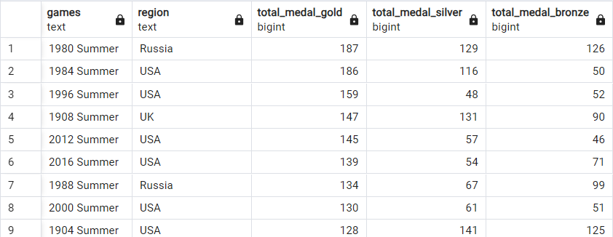

Anthor solution Using crosstab mean pivot table

SELECT country,

coalesce(gold, 0) AS gold,

coalesce(silver, 0) AS silver,

coalesce(bronze, 0) AS bronze

FROM crosstab('SELECT region AS country, medal, COUNT(*) total_medals

FROM athlete_events ae

JOIN noc_regions nr

ON ae.noc = nr.noc

WHERE medal <> ''NA''

GROUP BY country, medal

ORDER BY country, medal',

'VALUES (''Bronze''), (''Gold''), (''Silver'')')

AS RESULT(country TEXT, bronze BIGINT, gold BIGINT, silver BIGINT)

ORDER BY gold DESC, silver DESC, bronze DESC

16. Identify which country won the most gold, most silver and most bronze medals in each olympic games.

WITH cte AS

(SELECT SUBSTRING(game_country, 1, POSITION('-' in game_country) -1) AS game,

SUBSTRING(game_country, POSITION('-' in game_country) + 2) AS country,

coalesce(gold, 0) AS gold,

coalesce(silver, 0) AS silver,

coalesce(bronze, 0) AS bronze

FROM crosstab('SELECT CONCAT( games, '' - '', region ) AS game_country, medal, COUNT(*) total_medals

FROM athlete_events ae

JOIN noc_regions nr

ON ae.noc = nr.noc

WHERE medal <> ''NA''

GROUP BY games, region, medal

ORDER BY games, region, medal',

'VALUES (''Bronze''), (''Gold''), (''Silver'')')

AS RESULT(game_country TEXT, bronze BIGINT, gold BIGINT, silver BIGINT)

ORDER BY gold DESC, silver DESC, bronze DESC)

SELECT DISTINCT game,

CONCAT(first_value(country) OVER(PARTITION BY game ORDER BY gold DESC), ' - ', first_value(gold) OVER(PARTITION BY game ORDER BY gold DESC)) AS gold,

CONCAT(first_value(country) OVER(PARTITION BY game ORDER BY silver DESC), ' - ', first_value(silver) OVER(PARTITION BY game ORDER BY silver DESC)) AS silver,

CONCAT(first_value(country) OVER(PARTITION BY game ORDER BY bronze DESC), ' - ', first_value(bronze) OVER(PARTITION BY game ORDER BY bronze DESC)) AS bronze

FROM cte

ORDER BY game, gold DESC, silver DESC, bronze DESC

17. Identify which country won the most gold, most silver, most bronze medals and the most medals in each olympic games.

with temp as

(SELECT substring(games, 1, position(' - ' in games) - 1) as games

, substring(games, position(' - ' in games) + 3) as country

, coalesce(gold, 0) as gold

, coalesce(silver, 0) as silver

, coalesce(bronze, 0) as bronze

FROM CROSSTAB('SELECT concat(games, '' - '', nr.region) as games

, medal

, count(1) as total_medals

FROM athlete_events oh

JOIN noc_regions nr ON nr.noc = oh.noc

where medal <> ''NA''

GROUP BY games,nr.region,medal

order BY games,medal',

'values (''Bronze''), (''Gold''), (''Silver'')')

AS FINAL_RESULT(games text, bronze bigint, gold bigint, silver bigint)),

tot_medals as

(SELECT games, nr.region as country, count(1) as total_medals

FROM athlete_events oh

JOIN noc_regions nr ON nr.noc = oh.noc

where medal <> 'NA'

GROUP BY games,nr.region order BY 1, 2)

select distinct t.games

, concat(first_value(t.country) over(partition by t.games order by gold desc)

, ' - '

, first_value(t.gold) over(partition by t.games order by gold desc)) as Max_Gold

, concat(first_value(t.country) over(partition by t.games order by silver desc)

, ' - '

, first_value(t.silver) over(partition by t.games order by silver desc)) as Max_Silver

, concat(first_value(t.country) over(partition by t.games order by bronze desc)

, ' - '

, first_value(t.bronze) over(partition by t.games order by bronze desc)) as Max_Bronze

, concat(first_value(tm.country) over (partition by tm.games order by total_medals desc nulls last)

, ' - '

, first_value(tm.total_medals) over(partition by tm.games order by total_medals desc nulls last)) as Max_Medals

from temp t

join tot_medals tm on tm.games = t.games and tm.country = t.country

order by games;

18. Which countries have never won gold medal but have won silver/bronze medals?

WITH cte AS (

SELECT country,

coalesce(gold, 0) AS gold,

coalesce(silver, 0) AS silver,

coalesce(bronze, 0) AS bronze

FROM crosstab('SELECT region AS country, medal, COUNT(*) total_medals

FROM athlete_events ae

JOIN noc_regions nr

ON ae.noc = nr.noc

WHERE medal <> ''NA''

GROUP BY country, medal

ORDER BY country, medal',

'VALUES (''Bronze''), (''Gold''), (''Silver'')')

AS RESULT(country TEXT, bronze BIGINT, gold BIGINT, silver BIGINT)

ORDER BY gold DESC, silver DESC, bronze DESC)

SELECT *

FROM cte

WHERE gold = 0 and (silver > 0 or bronze > 0)

19. In which Sport/event, India has won highest medals.

SELECT sport, COUNT(*) height_medals

FROM athlete_events ae

JOIN noc_regions nr

ON ae.noc = nr.noc

WHERE medal <> 'NA' AND region = 'India'

GROUP BY sport

ORDER BY height_medals DESC

LIMIT 1

20. Break down all olympic games where india won medal for Hockey and how many medals in each olympic games.

SELECT games, sport, COUNT(*) height_medals

FROM athlete_events ae

JOIN noc_regions nr

ON ae.noc = nr.noc

WHERE medal <> 'NA' AND region = 'India' AND sport = 'Hockey'

GROUP BY games, sport

ORDER BY height_medals DESC

